# Free and featured this September at Cell Press

Filed to [Promoter](http://crosstalk.cell.com/blog/topic/promoter)

http://crosstalk.cell.com/hs-fs/hubfs/Headshots/meghan-gaucher.jpg?t=1478274396864&width=30&height=30&name=meghan-gaucher.jpg Posted by [Meghan Gaucher](http://crosstalk.cell.com/blog/author/meghan-gaucher) | Published September 28, 2016, 09:00

This month, Cell Press released free leading research from *Cell Reports*, *Chem*, *Cell Metabolism*, and *Cell*highlighting topics including a look at Zika infections in the eye, the evolution of beer yeasts over the last 100-plus years, a step forward in scanning techniques for bone imaging, and a benefit of calorie restriction.

Read on to discover more!

**Zika virus found in tears in a mouse model**

The Zika virus, transmitted by *Aedes* mosquitoes, continues to be a hot topic as more is discovered about its effects, how it spreads, where it spreads, and potential treatments to mothers and their offspring infected with Zika. It is known that adults with Zika can experience severe symptoms, including health disturbances and damage to the eyes. Babies infected with Zika have been born blind, and optical nerve and retinal damage has been found among those infected by the disease.

As though the thought of getting the virus from a mosquito bite wasn't daunting enough, the discovery of Zika genetic material in the eyes of Zika-infected mice has led researchers to suggest there may be another way to become infected with Zika—through tears—though at this time there are no confirmed cases of anyone getting the virus through this route.

[In a recent article published at](http://www.cell.com/cell-reports/fulltext/S2211-1247(16)31175-5)[*Cell Reports*](http://www.cell.com/cell-reports/home),[Jonathan J. Miner](https://medicine.wustl.edu/research/), Michael Diamond, and colleagues at the Washington University School of Medicine explore the effects of Zika on the eyes using a Zika-infected mouse model. The mice were examined seven days after being injected with the virus, and the researchers found that the mice developed a range of severe eye diseases that were also seen in people with Zika, including blindness and optic neuritis.

Notably, their findings showed that tears of Zika-infected mice contained genetic material from the virus a week after infection. However, the tears were not infectious. The genetic material, RNA, was found in considerable amounts in the eyes of the mice. Although the virus wasn’t live, the findings suggest that tears may be a means of passage for the virus to spread from human to human.

Miner and his team plan to explore further how Zika gets into the eye.

**Read more:**[Zika Virus Infection in Mice Causes Panuveitis with Shedding of Virus in Tears](http://www.cell.com/cell-reports/fulltext/S2211-1247(16)31175-5" \t "_blank)



**Science on tap**

Kevin Verstrepen and his team at the Centre of Microbial and Plant Genetics in (how fitting) Belgium trace the evolutionary history of beer yeasts in [a recent article published at *Cell*](http://www.cell.com/fulltext/S0092-8674(16)31071-6). If you've ever been curious about brewing processes and brewing strains and their vital role in the production of beer and wine, the findings that the Belgian research team and their partners at White Labs in America published are quite interesting.

Here are some highlights to consider the next time you sit to enjoy a cold alcoholic beverage:

1. We have been using yeasts to brew wine and beer since ancient times, even before science caught up with the times and discovered microbes.
2. Brewing strains used for beer production show strong signs of domestication. This is because brewers and wine makers often choose yeasts that retain their character under highly industrialized processes and can consume specific sugars with desirable flavor outcomes.
3. The repetition and longevity of the practice of "backslopping," an ancient technique used to maintain a particular strain of yeast (for desirable taste and consistency) when brewing more beer allowed the microbes to continually adapt and grow to fit market taste and the industrial environment. In fact, centuries of backslopping-domesticated yeasts have made beer more adaptable to the human palate.
4. The mapping out of genome sequences provided the scientists an understanding of how yeasts evolve over time in beer and wine.

Thirsty for more? Check out the full-text article, [in *Cell*](http://www.cell.com/fulltext/S0092-8674(16)31071-6)

**Read more:** [Domestication and Divergence of *Saccharomyces cerevisiae* Beer Yeasts](http://www.cell.com/fulltext/S0092-8674(16)31071-6)

[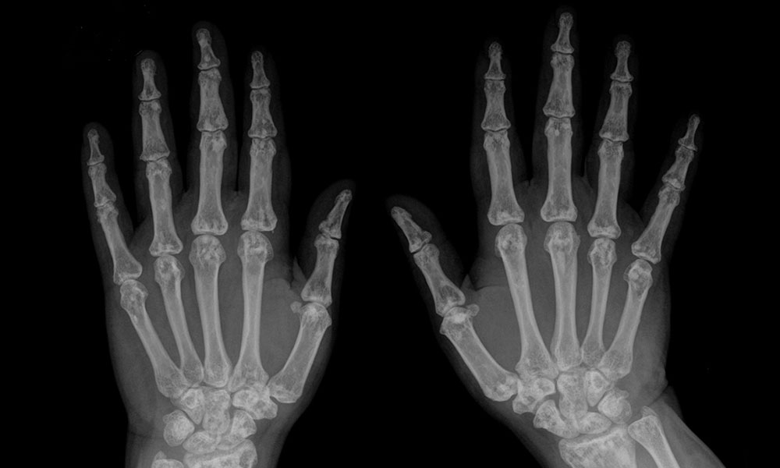](https://upload.wikimedia.org/wikipedia/commons/7/7c/Osteopoikilie_Haende.jpg)

**A new scanning technique provides a more-detailed look at bone damage**

A variety of scanning techniques are used every day by doctors and physicians in the medical field to view disruption to internal systems and damage in the body. Bone damage requires detailed, informative imaging for effective diagnosis and prognosis to be made. [*Chem*](http://www.cell.com/chem/home), Cell Press's first physical science journal, recently published [an article that introduces a new scanning technique that may help us gain insights about bone quality to properly assess bone damage](http://www.cell.com/chem/fulltext/S2451-9294(16)30113-9), which may lead to a better diagnosis.

In collaboration with RCSI, a team of chemists from [Trinity College in Dublin](http://chemistry.tcd.ie/staff/academic/) have conceived and invented a new 3D scanning technique using nanoagents that makes it possible to view high-resolution images of damaged regions of bones. Nanoagents are attracted to cracks in the bone, or rather the calcium-rich surfaces created by bone damage. Due to the nature of nanoagents, the imaging 3D map provides a clear image of bone damage microcracks.

Gold nanoparticles found in the scanning machine reduce the risk of cancer because X-rays are not emitted. In addition, the skin receives less damage because  the machine uses long-wavelength excitation to properly image the bones.

**Read more:** [Two-Photon Luminescent Bone Imaging Using Europium Nanoagents](http://www.cell.com/chem/fulltext/S2451-9294(16)30113-9)

**[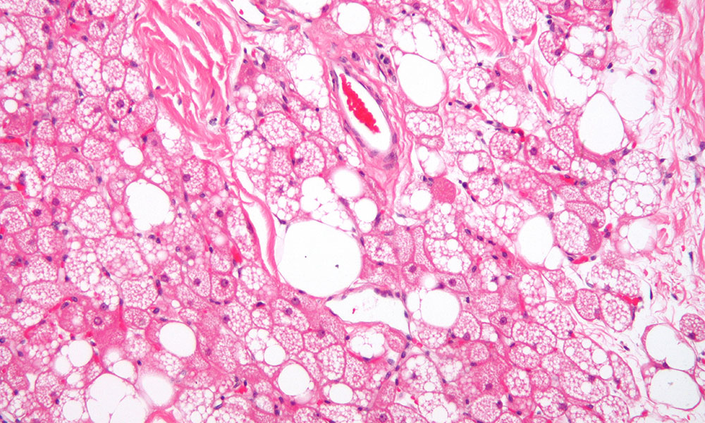](https://upload.wikimedia.org/wikipedia/commons/c/ca/Hibernoma2.jpg)**

**When white adipose tissue browns in dieting mice**

In [an article published at *Cell Metabolism*](http://www.cell.com/cell-metabolism/fulltext/S1550-4131(16)30374-6), Salvatore Fabbiano and colleagues at the [University of Geneva](http://www.unige.ch/medecine/phym/en/groupes/) report that severely restricting the caloric intake of mice promotes the browning of white adipose tissue and results in faster energy burning.

Our bodies use brown adipose tissue, a lean tissue often associated with good health, to "store" calories in the form of lipids to be consumed later in the event of starvation. Brown adipose tissue "burns" the lipids to provide body heat and maintain equilibrium. White adipose tissue, on the other hand, is a fatty tissue often associated with bad health.

The researchers discovered a "browning" of white adipose tissue in the control group of male mice fed a calorie-restricted diet when they were exposed to the cold and a lesser amount of browning in obese mice that were allowed to eat at will. The browning of white adipose tissue expressed more energy; further testing also showed that the browning changed the animals’ metabolism in the cold.

The mouse model clearly demonstrates the phenomenon of browning of white adipose tissue and provides insight into the effect of caloric restriction in mice.